

**System Analysis and Design (SECD2613)  
Phase 1- Project Proposal and Planning**

**Section** : 5

**Group** : 5

**Group Members:**

|  |  |
| --- | --- |
| **NAME** | **MATRIC NO** |
| CHU CHENG QING | A23CS0218 |
| TAN ZHEN LI | A23CS5025 |
| TEOW ZI XIAN | A23CS0279 |
| ABDULLAH AL TOUFIQ | A23CS4033 |

**1.0 Introduction:**

The manual management of pet supply stores is becoming outdated in the fast-paced world of today. We now have the chance to relieve business owners of the challenges they face while improving the way they manage inventory thanks to the quick development of technology. The goal of this project is to create an up-to-date pet inventory supply system proposal that will improve operational accuracy and efficiency while also making store owners' work easier.

We can put an end to the time of laborious methods for inventory management by setting this system into place. Instead, we encouraged automation and systematic planning, which helps store owners save money and time. The technology reduces the risk of errors by using fewer employees, ensuring that inventory tasks are completed accurately all the time.

Our system enables store owners a way to easily manage their inventory by utilizing cutting-edge technology like bar code scanning and real-time tracking. Every aspect of inventory management is optimized for optimal efficiency, from monitoring product expiration dates to creating automated reorder notifications.

For business owners, this pet inventory management system is essentially an advancement of the managing process. By utilizing technology, we're creating a more promising future for the pet supply business, one in which store owners can concentrate on offering outstanding goods and services and delegate the tedious chores to our creative system.

**2.0 Background Study:**

Pet supply stores have traditionally relied on laborious, error-prone manual inventory management ways. Despite the availability of barcode scanning technologies, counting stocks and stocks expiry detection continue to cause problems with the stores' management. The primary reason for this is the improper integration of barcode scanning technology with current inventory management systems, which makes it impossible to check stock levels and expiry dates in real time. Furthermore, a few retailers still do inventory operations manually, which increases the risk of mistakes and delays. Additionally, the wide variety of goods that are sold in pet supply stores makes inventory management more difficult because barcode scanning might not be able to capture all relevant product information, such as perishable item expiration dates. Because of this, pet supply stores frequently find it difficult to keep up-to-date inventory records and efficiently satisfy consumer’s demand.

**3.0 Problem Statement :**

One of the keys to success in the constantly shifting retail pet supply market is effective inventory management. Even still, a lot of pet supply companies are facing a lot of difficulties in this crucial field despite technological developments. Several problems are found to enhance the pet supply retailers.

1. Manual Inventory Management: Pet supply stores often rely on manual methods for inventory management, leading to errors, inefficiencies, and discrepancies between actual stock levels and recorded inventory.
2. Limited Integration of Technology: While some stores have adopted barcode scanning technology, there's a lack of integration with advanced inventory management systems. This limits real-time visibility into stock levels, expiration dates, and overall inventory tracking capabilities.
3. Complex Product Variability: Pet supply stores carry a diverse range of products, including food, toys, accessories, and medications, each with unique attributes and expiration dates. Managing this variability manually is challenging and prone to errors.
4. Resource Constraints and Training Challenges: Some stores lack the resources or expertise to implement barcode scanning technology effectively. Training staff to use new technologies and overcoming resistance to change can be time-consuming and challenging.
5. Inefficient Order Fulfillment: Without real-time visibility into stock levels and automated ordering processes, pet supply stores may struggle to fulfill orders accurately and in a timely manner, leading to customer dissatisfaction and lost sales.
6. Risk of Expired Products: Failure to monitor expiration dates effectively can result in the sale of expired products, leading to potential health risks for pets and reputational damage for the store.

**4.0 Proposed Solutions to Address Inventory Management Challenges:**

The implementation of an advanced pet inventory management system could significantly improve operating efficiency and accuracy for pet supply businesses. Reliable software that includes barcode scanning technology enables stores to efficiently monitor expiration dates, automate inventory tracking, and obtain real-time stock level information. Inventory processes have been simplified and decision-making is improved by this seamless integration. Inventory retrieval becomes easier by standardized product labeling and categorization, which also ensure consistency and lower error rates. Staff members can utilize the system efficiently and maximize its benefits when it has a straightforward user interface, thorough training, and support. Automated ordering procedures and real-time stock monitoring speed up order fulfillment, increasing customer satisfaction and reducing revenue lost. Additionally, automatic expiration date monitoring can track the products that have expired or nearly expired, preserving the reputation of the business and protecting pet health.

**4.1 Technical Feasibility:**

The current IT infrastructure of the client stores is supposed to work with the new pet inventory management system. This ensures smooth integration without requiring major modifications or changes to the systems that are in place. We will evaluate the system to make sure it complies with the following requirements:

* Technology Compatibility:

Our new system’s hardware and software are expect to be met by the client stores’ existing IT infrastructure.

* System requirements:

We are able to define what are the hardware, software and network specifications needed to achieve integrating technologies like barcode scanning, automatic stock expiration notifications and real time inventory tracking.

* Expertise Availability:

Further training for software development, database administration and certain system developing skills are needed in order to build up the system.

**4.2 Operation Feasibility:**

Operational feasibility evaluates whether an organization's stakeholders and processes can adjust to the system and how it will be implemented within its current operational framework. Some ideas to think about for this system are:

* User Acceptance:

The managers and staff members of the stores should be able to accept the new system after we clearly build up a system that can satisfy their needs.

* Process Integration:

After a simple training made for the managers and staff members, they should be understand on how the new system will work with the stock management, purchasing, sales processing, and customer management procedures.

* Training Needs:

A simple training would be necessary for both the manager and staffs understand how would the system work in order to facilitate it completely.

**4.3 Economical Feasibility:**

The analysis of economic feasibility determines if the system's financial advantages outweigh its drawbacks. To determine the project's prospective, a cost-benefit analysis is included. Important things should be included are:

* Development Costs:
  + Hardware - RM20,000
  + Software & Licensing Tools - RM15,000
  + Research & Internal Design - RM5,000
  + Testing & Quality Assurance - RM5,000
  + Initial Documentation - RM4,000
* Operational Costs (Annual):
  + Support & Maintenance - RM8,000
  + Updates & Upgrades - RM8,000
  + Training & Retraining - RM5,000
  + Subscription Fees - RM3,000
  + Hosting & Infrastructure - RM5,000
* Benefits:
  + Increase Revenue - RM20,000
  + Cost Savings - RM60,000
  + Reduced Risks - RM10,000
* Assumptions
  + 5% of annually increase in production costs
  + 5% of annually increase in benefits
  + discount rate of 10%
* Uncertainties:
  + 1.1 sensitivity factor (costs)
  + 0.9 sensitivity factor (benefits)
* Cost-benefit Analysis:

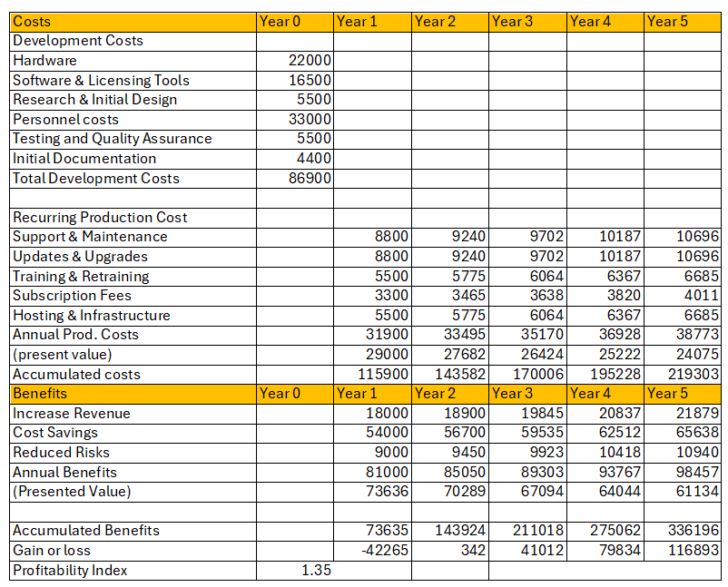

Since the PI value is greater than 1, this project is said to be rewardable in a 5 years time frame.

**5.0 Objectives:**

In order to improve the overall management, accuracy and efficiency of the pet supply stores, few objectives are proposed to enhance the inventory management practices.

1. Implement Advanced Inventory Management Systems:

We aim to provide a reliable software for inventory management that works well with barcode scanning. This system ought to automate inventory tracking procedures, give real-time stock level awareness, and have expiration date management functions. Pet supply stores may lower errors, increase productivity, and guarantee correct inventory records by switching from manual to automated systems.

2. Enhance Integration of Technology:

Invest in comprehensive inventory management solutions that connect sophisticated inventory management systems with barcode scanning technologies. Pet supply stores can obtain real-time insights into stock levels, expiration dates, and general inventory tracking capabilities by providing seamless connectivity. This integration gives store owners the ability to make well-informed decisions and streamlines inventory management.

3. Simplify Product Management:

Provide standardized procedures for product labeling and categorization to make inventory retrieval and tracking easier. Pet supply stores can guarantee consistency in inventory records and minimize errors related to complicated product variability by streamlining their product management procedures. This method improves efficiency and accuracy when handling a variety of product lines.

4. Offering a user-friendly interface:

Our system will have intuitive features and user-friendly interfaces to make it easier to use and reduce the learning curve for retail employees. As part of the installation process, we will also provide thorough training programs to make sure staff members are competent in using the system successfully. In addition, our system will come equipped with integrated support tools including tutorials, troubleshooting manuals, and instant support to handle any questions or issues that may come up during daily business operations. Through the provision of continuous assistance and staff training, our system enables pet supply stores to optimize the advantages of technology.

5. Optimize Order Fulfillment Processes:

Use real-time stock level monitoring and automated ordering procedures to reduce wait times and expedite order fulfillment. Pet supply stores can increase customer satisfaction and lower the possibility of missed sales by reliably and promptly filling orders by automating ordering procedures and providing better visibility into stock levels.

6. Implement Expiration Date Monitoring:

Prevent the selling of expired goods by implementing automatic expiration date monitoring systems. Pet supply retailers can reduce the possibility of possible health risks for pets and lessen the harm to their reputation by keeping a close eye on expiration dates and giving priority to the sale of products that are about to expire.

**6.0 Scope of the project:**

Pet supply stores will have access to an advanced inventory management system with a variety of features, functions, and user interfaces designed to increase productivity, accuracy, and management quality. This scope describes the features and intended users of the system.

1. System Functions
   1. Inventory Tracking

The inventory tracking will be automated by the system, which will provide stock level updates in real time. This will guarantee that employees and store managers always have a clear understanding of the products that are available. Staff will be notified when inventory levels are low, enabling them to place new orders and lowering the possibility of stockouts.

* 1. Barcode Reading

By integrating barcode scanning technology, errors in manual product entry can be reduced and efficient product entry into the system can be achieved. The technology automatically updates inventory data when a product is scanned, saving staff time and offering real-time insights into stock levels.

* 1. Expiration Date Management

The system will automatically check the expiration dates of all perishable commodities in order to prevent the sale of expired goods. When a product's expiration date approaches, it will send out reminders so that employees may prioritize selling it. In addition to preserving consumer safety and product quality, this function safeguards the store's reputation.

* 1. Order Fulfillment

Order processing will be streamlined by the system from start to finish. The ability to view order progress in real-time helps store employees handle orders more effectively, leading to accurate and fast fulfillment. Errors are decreased, and customer satisfaction is raised.

* 1. Product Management

Streamlining the labeling and classification of products will make inventory retrieval and tracking easier. For improved control, the system will manage products in batches and guarantee consistency in inventory records. This would enhance handling of the wide variety of products offered in pet supply stores in terms of accuracy and efficiency.

* 1. User-Friendly Interface

The system will have an intuitive design that is simple for all users to navigate. Integrated training modules and support tools will enable new users learn how to utilize the system efficiently.

1. System users
   1. Store Managers

Store managers will be responsible for overall inventory management, making informed decisions based on real-time data. They will have access to thorough information, keep an eye on inventory levels, approve orders, and manage supplier connections. The system will provide managers with the tools they need to operate their stores efficiently.

* 1. Store Staff

The employees at the store will manage daily interactions with the inventory system. Barcode scanners will be utilized for product entry into the system, order processing, and stock level updates. Store employees will ensure inventory accuracy and product availability by managing tasks including acquiring stock and keeping an eye on expiration dates.

**7.0 Project Planning**

**7.1 Human Resource:**

**Project Manager:** Chu Cheng Qing will responsible to lead the entire project from start to finish, making sure everything goes according to plan and meets deadlines. He also communicate with everyone involved in the project and manage resources effectively.

**Business Analyst:**

Teow Zi Xian will responsible to gather and analyze what the business needs for a project, then turn those needs into clear instructions for the development team.

**System Architect:**

Tan Zhen Li will design the big picture of how a system will work, including what software it will use and how everything will fit together.

**UI/UX Designer:**

Abdullah Al Toufiq is in charge of making sure a system is easy and pleasant to use by designing its appearance and layout.

**Software Developers:**

**Frontend Developers:** Teow Zi Xian will help to build the parts of a system that users interact with directly, like web pages or mobile apps.

**Backend Developers:** Chu Cheng Qing create the behind-the-scenes parts of a system that handle data and processes, making sure everything runs smoothly.

**Quality Assurance (QA) Engineers:**

After the frame of the system was designed, Tan Zhen Li will test the system to find any problems or areas where it could be improved, making sure it works as intended.

**Technical Support Specialists:**

Abdullah Al Toufiq will help users when they have trouble with a system, whether it's during setup, everyday use, or if something goes wrong.

**Trainers:**

Every of the team members will teach people how to use the system, providing guidance and support to ensure users feel comfortable and confident.

**Database Administrators (DBAs):**

Teow Zi Xian will manage the data storage and retrieval system that a system relies on, ensuring everything runs smoothly and securely.

**System Administrators:**

Abdullah Al Toufiq will handle the technical aspects of keeping a system running smoothly, managing servers and other hardware.

**Change Management Specialists:**

Tan Zhen Li will help organizations transition smoothly when introducing a new system, ensuring everyone understands and adapts to the change

**7.2 Work Breakdown Structure**

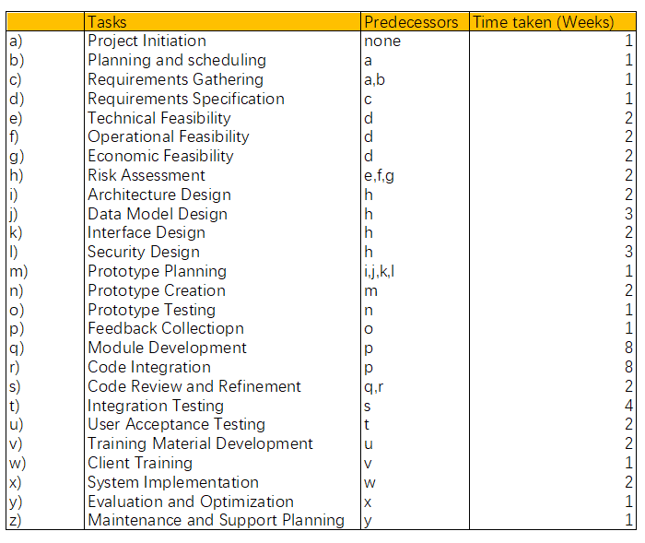

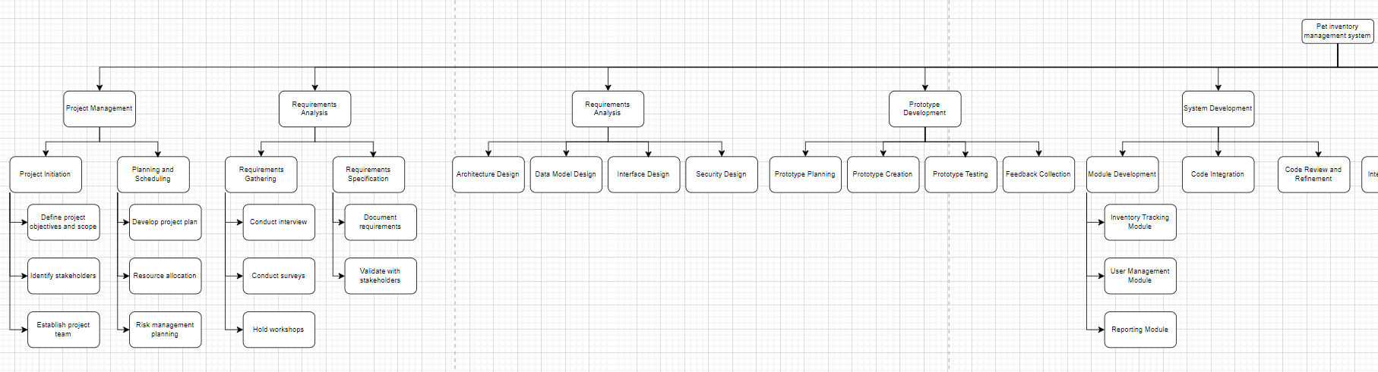

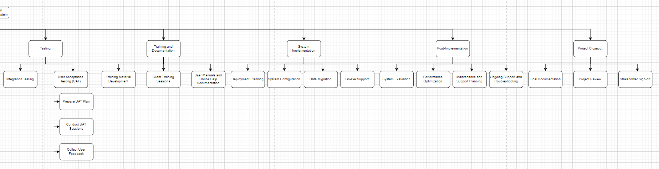

Diagram link:

<https://drive.google.com/file/d/1Pc9Nj4XOQqScK29xi6PHsNSJaGGD5w-a/view?usp=sharing>

**7.3 PERT Chart**

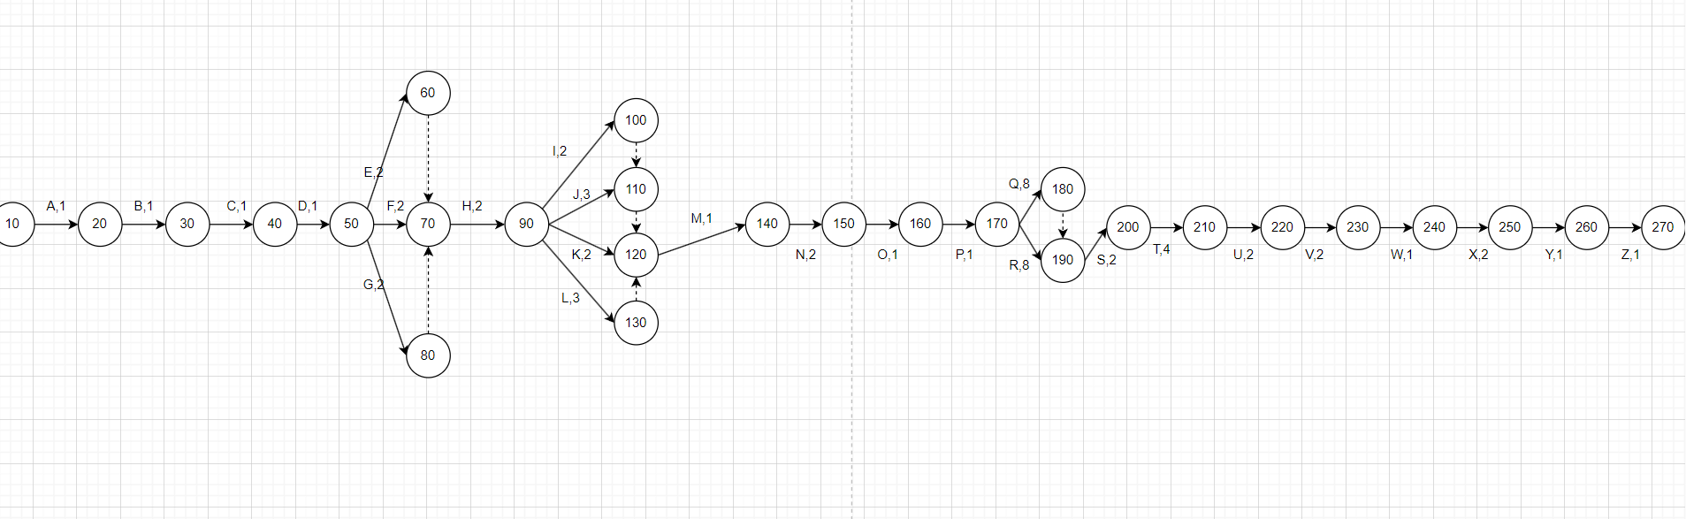

Diagram link:

<https://drive.google.com/file/d/1yR8Rddq4R4coUrY4ESwmXfdpcq1D8w7f/view?usp=sharing>

note: use draw.io to see the picture

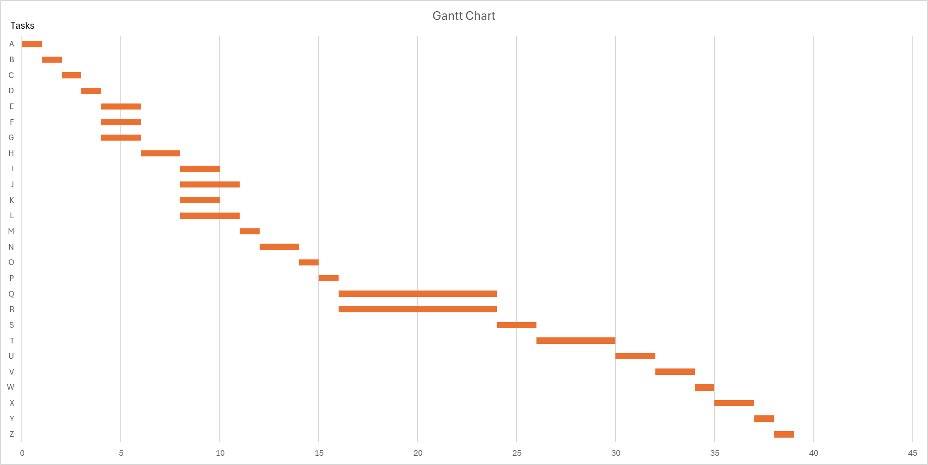**7.4. Gantt Chart**

**8.0 Benefit and Overall Summary of Proposed System**

The proposed pet inventory management system offers an integrated strategy designed to completely transform the way pet supply stores operate. Basically, the system's goal is to reduce the amount of manual labor that store managers and owners must hire, providing a smooth and effective solution for conventional inventory management techniques. The system claims to bring in a new era of operational excellence marked by reduced procedures and increased production by utilizing technology.

The suggested solution aims to directly solve major difficulties in the sector with a priority on reducing pain points. These problems include the broad adoption of manual inventory management methods. insufficient technological integration, and the complexity of monitoring a wide range of product variations. By improving operational efficiency and reducing risks related to stock management, the system delivers a full solution by automating inventory tracking, optimizing stock levels, and delivering early notifications for expiring products.

Furthermore, lots of advantages are anticipated from the suggested approach for both customers and store owners. By eliminating losses from expired or out-of-stock items, managing inventory levels, and cutting work hours, the system offers store owners the chance to gain large cost savings.

Also, by providing store owners with useful insights and analytics, the system facilitates data-driven decision-making and strategic planning that promotes business expansion.

The advantages are similarly obvious for customers at the same time. By increasing overall consumer satisfaction, cutting wait times, and improving product availability, the system guarantees a flawless shopping experience.

In conclusion, the proposed strategy for the pet inventory management system offers pet supply vendors an innovative opportunity to improve their operations and maintain an advantage in an increasingly competitive sector. The proposed solution, by utilizing automation and technology, not only solves current problems but also opens up possibilities for increased productivity, reduced expenses, and increased income.The suggested method has the ability to completely change the way pet supply companies handle their inventory. It also has the potential to redefine industry norms and open the door to a more efficient and customer-focused manner of conducting business.

**GitHub Link:** <https://github.com/CQ0113/Group5_Project1_SAD_20232024>

**Repository Snapshot:**

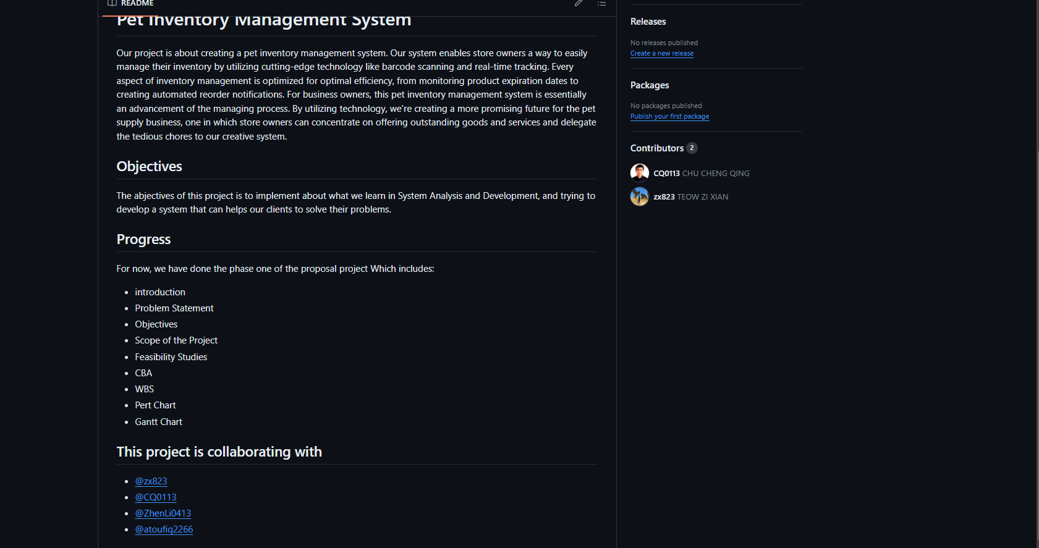

**Kanban Board Integration:**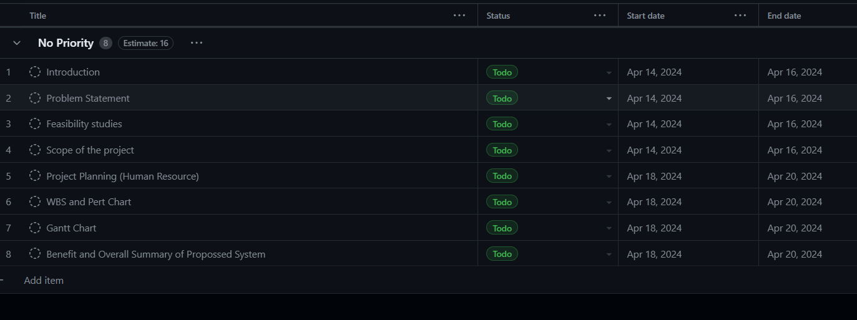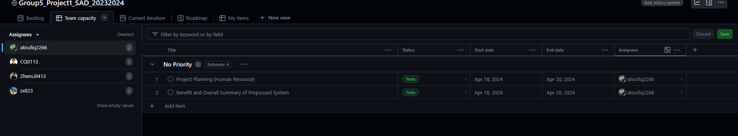

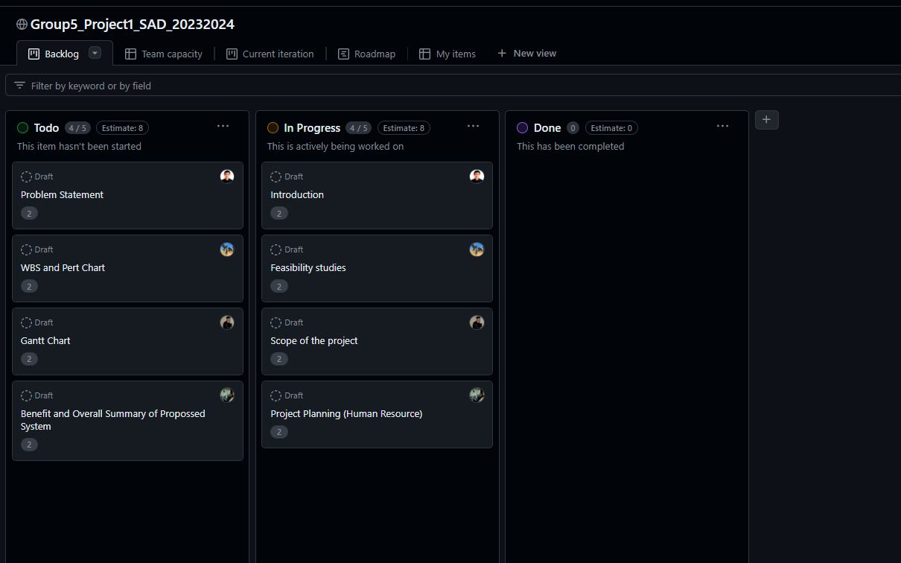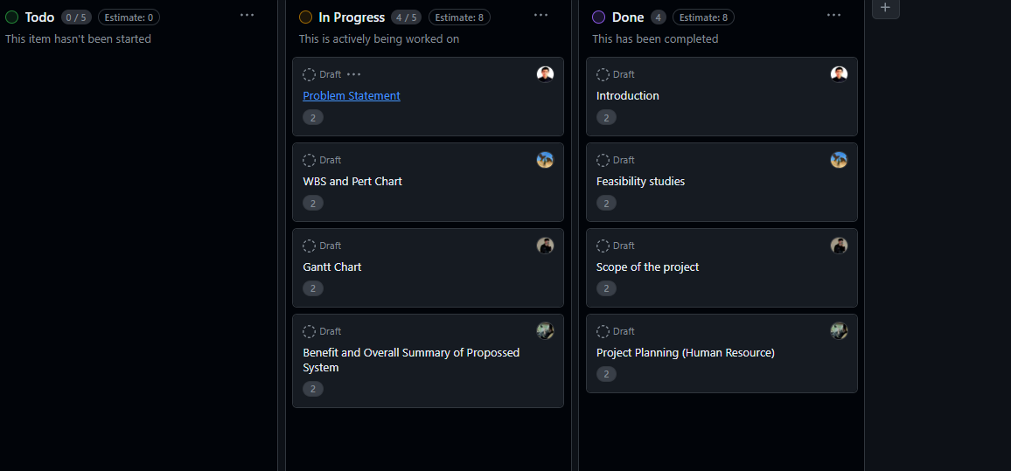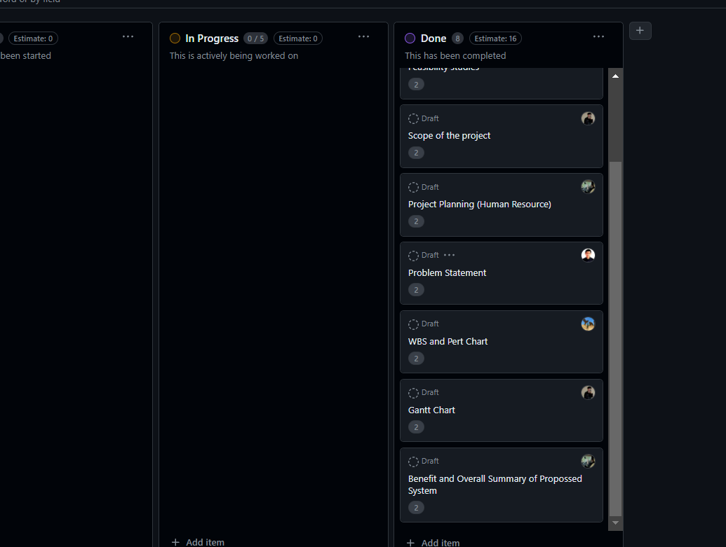

Project was begin with listing out to do tasks together with the timeframe we plan to complete the respective parts.

Then a meeting was held to distribute all the tasks to the members respectively.

Each member has to complete their tasks in 2 days.

Members are using the Kanban Board to update their status.

At last we managed to complete the project on time.